This Emergency Action Plan should be read in conjunction with the Risk Assessment for this facility.

Venue: | Harbour Lanesboro, At Pontoon
EAP created by: | James Gallagher Level 1 Coach |  | Date Created: | 23/06/2020
Venue Address: (Inc. Postcode/ Grid Reference) | Pontoon, Harbour Lanesboro,  Commons North  Lanesboro  Co Longford  53.671197, -7.993659
Type(s) of Activity this EAP applies to: | LTC Open Water Swimming Sessions.
Who is ultimately responsible for Health & Safety during these sessions:
 | Coaches /  Session Activator | There are no venue staff on site during sessions. It is an area of Lough Ree which is maintained by Waterways Ireland.
How will venue staff be contacted in emergency: | N/A
Location of Phone/Mobile Reception Tested: | - Mobile Phone reception is good. 4G reception covers site.  - No Landline on site.  - Landline at SUPERVALU supermarket, beside entrance to the harbour.
Location of the nearest first-aid qualified person: | Coaches are all First Aid qualified.
Location of first-aid equipment: | First aid box with Coach (provided by LTC). Also, spares in LTC Club Room, on wall.
Location of Defibrillator: | Front wall of Parish Hall beside Bridge. At entrance to old Harbour.
Non-Managed Venues
How to contact Emergency Services: | Dial 999 or 112.
How will Emergency Services be directed to the scene of an incident: | If there is an incident, person responsible (Lead Coach) will use two Members to stand on main road and direct ambulance in via emergency vehicle access road to designated landing point at the pontoon.
Who else is available to help in case of issues: | Coaches who are all first aid trained.

Actions required in specific situations (to be completed by the Coach directly or delegated as appropriate)

Evacuation:  Consider COVID-19 best practice when dealing with the evacuation. | - If anyone suspects fire/gas leak/electrical storm or severe weather or other reason to evacuate, they must alert all participants and Coaches. Move to Evacuation Point A or B, car park and green area adjacent to site (see map).  - Ensure that no-one returns to the Pontoon to collect their belongings.  - Coaches to ensure all participants and coaches evacuate the Pontoon and congregate in the main car park Evacuation Point A, next to parking lots, or if exit is blocked due to fire congregate on adjacent green area Evacuation Point B.  - Check all participants accounted for against the attendance record.  - If anyone missing, notify any emergency services present.  - Do not return to the pontoon until instructed to do so by emergency services.

Minor Injury:  Consider COVID-19 best practice when dealing with the injury. | - Upon discovery of a casualty with minor injuries, the Coaches should be informed, and should consider whether the participant needs treatment and if the treatment will impact on management of the coached group. If appropriate, consider handing responsibility for the group to another Coach temporarily while the casualty is being dealt with.  - If injury occurs on the water, kayaker/safety craft to assist injured person to shore.  - First aid should only be given by a qualified First Aider.  - The First Aider for the session will normally be the Coach.  - Coaches should remember to consider the safety of other participants and stop / suspend the session if they are distracted by dealing with the casualty.  - The First Aider should treat the casualty in accordance with their training and qualification guidance.  - When treating a casualty, do not leave yourself in a compromising position e.g. male First Aider alone with a female casualty or single adult with a child.  - The LTC Training Co-ordinator should be informed of any minor injuries so that relevant documentation can be completed.  - Coaches should follow the LTC accident reporting procedure (see latest LTC - Senior Club - Safety Briefing) including noting the incident on the session plan and completing an incident / accident report form.

Major Injury:  Consider COVID-19 best practice when dealing with the injury. | ALL CASES OF HEAD INJURY SHOULD BE TREATED AS SERIOUS!  - Make all Coaches aware by shouting “Coaches - Emergency”  - All Coaches stop session immediately. Delegate Coach/Senior Member to contact emergency services. Dial 999 or 112.  - If injury occurs on the water, kayaker/safety craft to assist injured person to shore, to the designated landing point.  - Get all swimmers out of the water, and move them away from casualty. If possible designate an assistant Coach, Parent or Senior Member to manage the group.  - Support kayaker and Coach – likely actions required: if casualty is in the water, kayaker/safety craft should manage the situation but Coach can offer assistance if required.  - Coaches will have first aid kit in their kit bag. Coach nearest the Parish Hall should go and get Defibrillator immediately from front wall, and bring back to casualty. Defibrillator is on the front wall of Parish Hall beside Bridge. It is not locked.  - Remaining Coach(es) should attend to the casualty in accordance with their training and qualification guidance and manage/direct all other participants at the session and move them away from the injured participant.  - For adult sessions, it may be possible to delegate responsibility of managing the group to a Training Committee member or Senior Member, so they can assist other Coaches. It may be that there are medically trained individuals at the session who can provide assistance. Make sure to ask but do not expect or rely upon it. First Aider will be identified during the briefing.  - Await arrival of emergency services, continuing to treat casualty, assist them and hand over when they have taken responsibility.  - Provide emergency services with details of any medication, known medical history and, in case of emergencies, contact details for the person injured. Check the session attendance record and request any relevant information from a member of the Training Committee who should be able to access additional information that is securely maintained by the Training Committee.  - Coaches should follow the LTC accident reporting procedure (see latest LTC - Senior Club - Safety Briefing) including noting the incident on the session plan and completing an incident / accident report form.  - Notify key stakeholders, as appropriate, including:  - Coach - James Gallagher (086-0238889)  - Training Co-Ordinator – Bernie Smith (087-7636260)  - Chairperson – Paddy Dowling (086-8288058)  - Secretary – Kate Donlon (087-9137642)

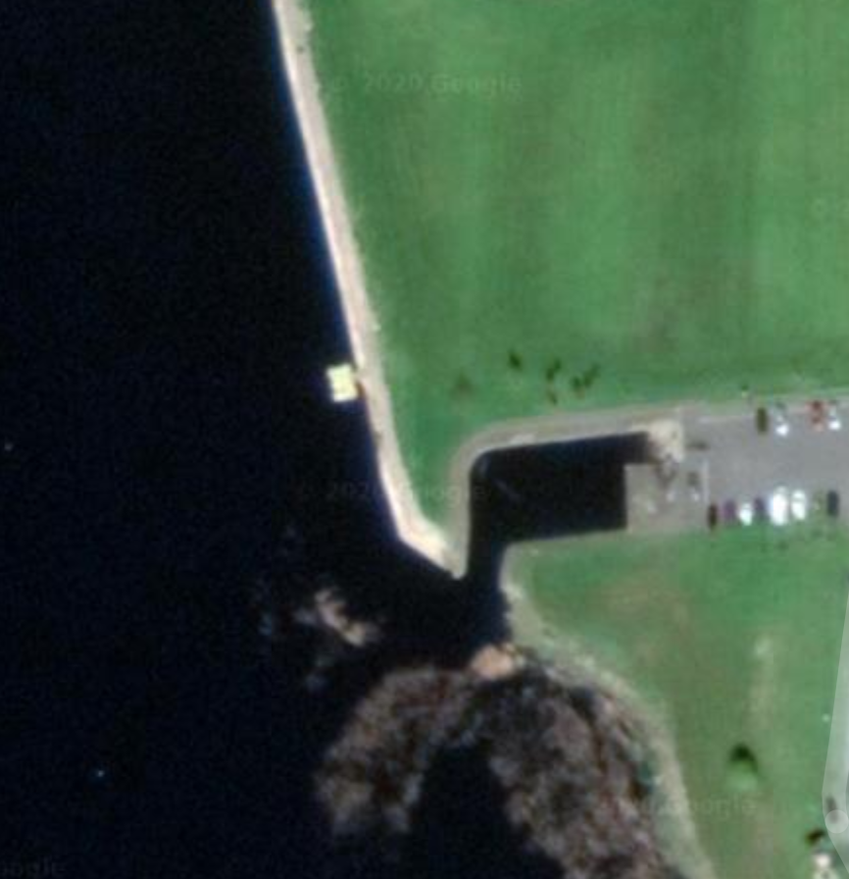
Designated Landing Point
Pontoon
Evacuation Point B
Evacuation point A
100m
50m
50m
Image of Old Harbour Lanesboro and Pontoon (Outdoor)

